  
**VALLEY VIEW SCHOOL**

**BANESHWOR, KATHMANDU**

NAME: **KRITAGYA BHATTARAI**

ROLL NUMBER: **15**

TEACHER’S NAME: **RANJEET RAI**

TEACHER’S DESIGNATION: **COMPUTER TEACHER**

TO: **DIGI SCHOOL**

**LETTER OF APPROVAL**

This is to certify that this project prepared by Kritagya Bhattarai, titled “Popup file generator”, in partial fulfillment if this requirement for the final project has been evaluated. In our opinion, it is satisfactory in scope and quality as a project.

...................................................

Krishna Prasad Mainali

Coordinator

.....................................................

Ranjeet Rai

Computer Science

Date: 28 Feb 2023

**ACKNOWLEDGEMENT**

This report was prepared as partial fulfillment of the Digi Curriculum requirement. An effort has been made to ensure that the report is accurate and professional as far as possible.

I’d like to start the acknowledgment by thanking our subject teacher, Mr. Ranjeet Rai Sir, my parents, Mr. Krishna Prasad Bhattarai and Mrs. Buddhamata Khanal Bhattarai, Digi school, and my Internet connection. With the help of everyone mentioned, I was able to completer this project. I express gratitude from the deepest part of my heart to everyone that helped me.

**EXECUTIVE SUMMARY**

This report was prepared as partial fulfillment of the Digi Curriculum requirement. This report has been divided into three parts. The first chapter, “Introduction”, includes a brief introduction to my report.

This report contains information about the inner and outer workings of my project. Things such as the tools and libraries I used in my project, the source of information I used to prepare this project, what this project is for, the limitations of this project, an explanation of the project, the final product, etc.

**You can find the project here: https://github.com/CalfMoon/school-project**

**TABLE OF CONTENT**

1. Main Body
   1. Introduction
   2. Objective
   3. Scope of the Project
   4. Limitation
   5. Project Explanation or Main Body
   6. Results and Discussions
2. Recommendation
3. Conclusion
4. References
5. Appendices
6. **Main Body**
   1. **Introduction**

This project, “Poput File Generator”, can be used to generate popup files. The way this project works is by creating a VBScript file, which has the extension ‘.vbs’. VBScript, as the name suggests, is a script file. This file can be used for many purposes, but I used it to generate popup messages. With the open and write function from python, I am able to generate a VBScript as directed by the user. I also used a library called customtkinter, which is based on tkinter, to create a GUI for this application.

* 1. **Objective**
     + To provide a GUI for creating VBScript.
     + To make the process of creating VBScript faster.
     + To make the power of VBScript available to non-technical users.
  2. **Scope of the Project**
     + This project is going to cover the use of VBScript to generate popup files.
     + This project will also cover the use of customtkinter package in order to GUI.
     + This project focuses on usability.
  3. **Limitations**
     + Vbs script only works in the windows operating system and requires a compatibility layer to work in another operating system.
     + This program requires the user to download customtkinter package through pip.
     + If the cancel button is hit while browsing the file creation directory, the user is returned to the current working directory.
  4. **Project Explanation**

This project was created with the help of a programming language called python, which was created by Guido van Rossum around December 1989. This project also uses pip, python’s package installer, in order to install a package called ‘customtkinter’, with is a tkinter-like package which is used to create modern-looking GUI more easily than by using tkinter.

In order to create this project, three packages were used, customtkinter, tkinter and os. Customtkinter was used to create the GUI itself, tkinter to create the menu to browse files, and os to get the working directory and to join the selected directory and file name.

In order to create the actual popup file, it’s just a 7-line function. The first two lines call another function to check if any of the input boxes are empty, mark them with red if they are empty and also exit out of the function with the help of an empty return statement. The following three lines are responsible for reading the name, title and content of the user entered. And the last two lines take that data and write that to a file in a meaningful way using the open() function from python, which is built into the library of python.

* 1. **Results and Discussion**

The final product of this project is a modern looking 410x300 box with three input boxes to enter data, with labels of these written on them in gray text, which turns to red of the create button is pressed without filling those boxes. There is also a browse button, which changes the directory in which the file will be created. This button is located beside the directory where the file will be created. And finally, there is create button at the bottom of the page, which, when all conditions are fulfilled, will create a new VBS file at the specified location.

**Project Link: https://github.com/CalfMoon/school-project**

1. **Recommendation**
   * + We should start by creating a basic outline of the problem that we want to solve.
     + Write function(s) to solve that problem.
     + Create GUI that calls the function with user-specified parameters.
2. **Conclusion**

This is a report written for the project “Popup file Generator”, which uses python to create a VBS script file with the file’s content as described by the user in the program. This program achieves the goal of making the power of generating popup scripts available to non-technical users. This report contains the summary, inner and outer workings, objective, scope, limitations and other details of the project.

1. **References**

<https://github.com/TomSchimansky/CustomTkinter/wiki>

<https://www.geeksforgeeks.org/>

<https://www.youtube.com/>

[https://schoolworkspro.com](https://schoolworkspro.com/)/

1. **Appendices**
   1. **When it opens:**

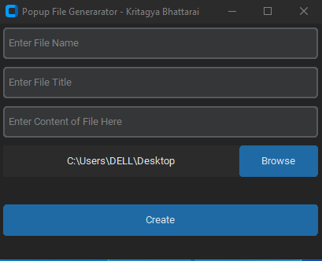

* 1. **When the create button is pressed without entering data:**

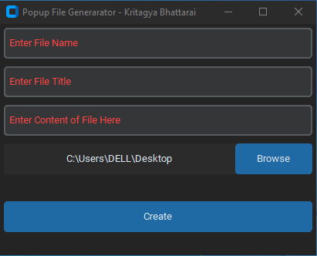

* 1. **With entered data:**

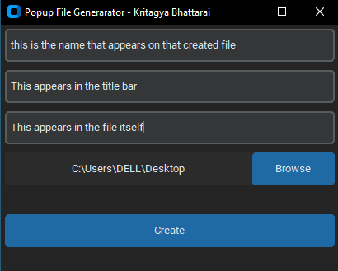

* 1. **How the created file appears:**



* 1. **The created file when it runs/opens:**

